L&C Site B
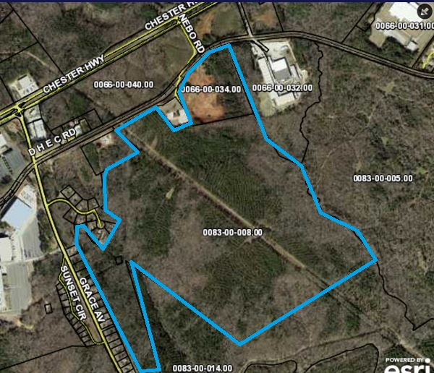

Enter property description.

Location | SC9 and Nebo Road Lancaster, SC
Price | $40,000
Size | 353 Acres
Additional Acreage Available | 231 acres
Water | City of Lancaster
Sewer | City of Lancaster
Electricity | Duke Energy
Natural Gas | Lancaster County Natural Gas Authority
Fiber | Comporium Communications
Connectivity
Highway | SC 9 (1/4 mile)
Interstate | I-77 (13 Miles)
Rail | Lancaster and Chester
Air | Charlotte Douglas International Airport (48 Miles)
 | McWhirter Field-General Aviation (1 Mile)
Additional Information | Click or tap here to enter text.

Contact

Jamie Gilbert
Director of Economic Development
(803) 286-3633
jgilbert@lancastercountysc.net

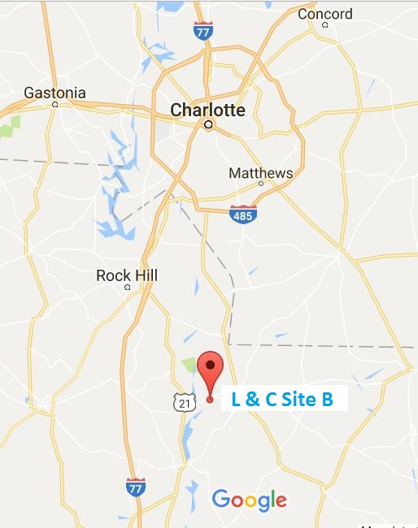 | 